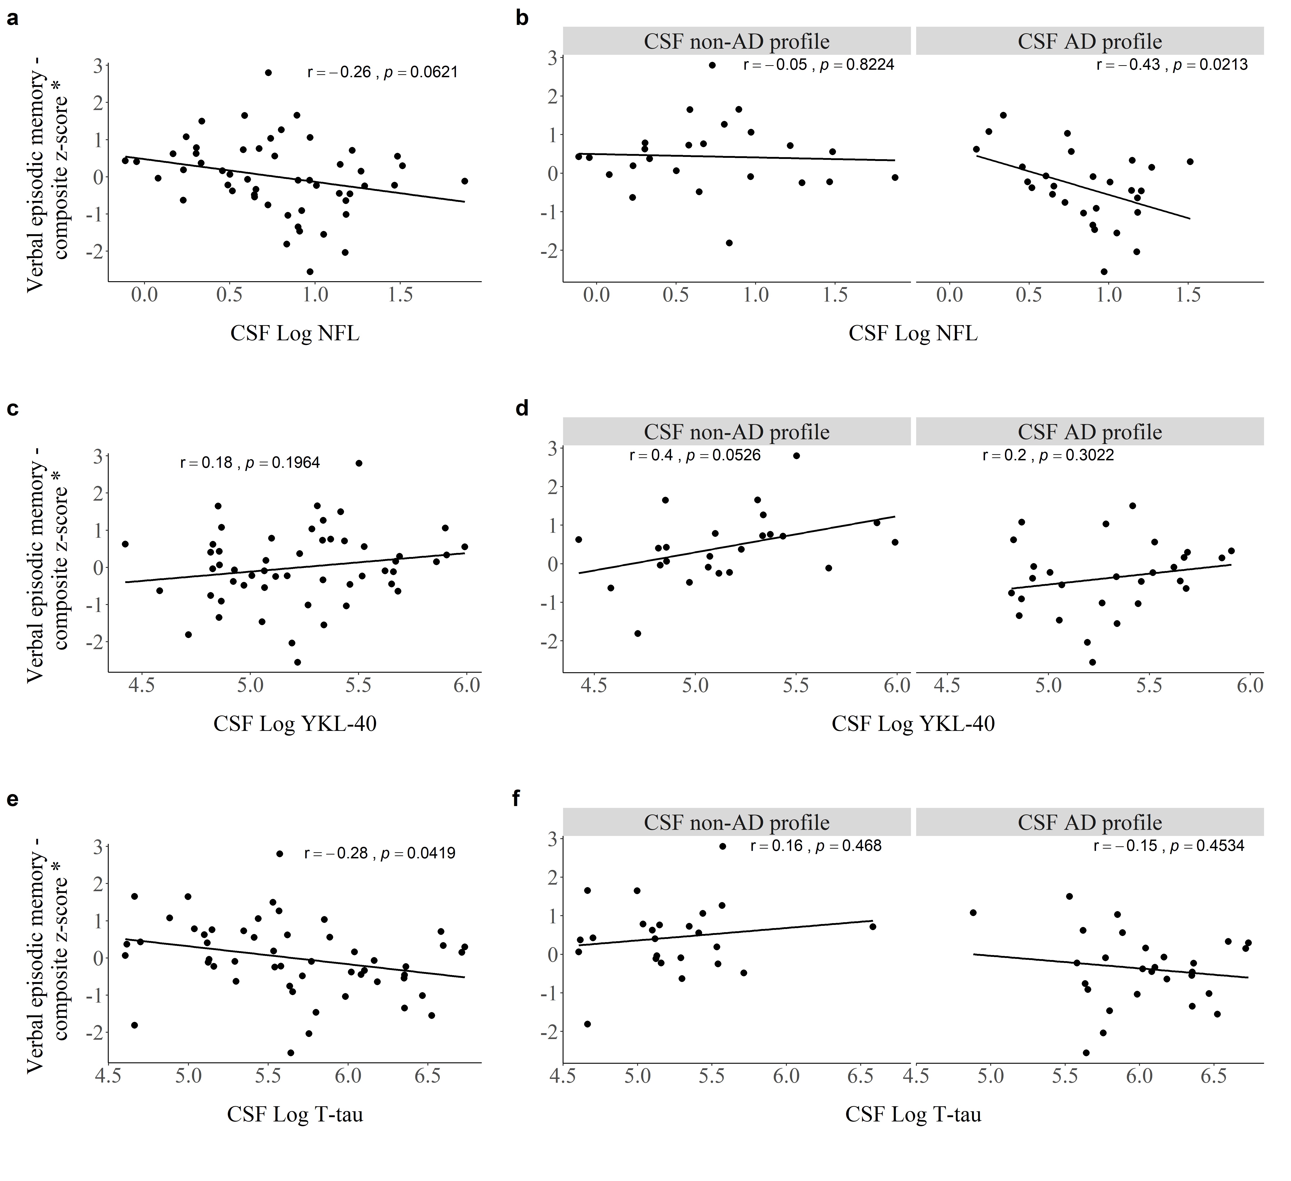
Fig. S1 Pearson‘s correlations between levels of CSF NFL (a,b), YKL-40 (c,d), T-tau (e,f) and verbal episodic memory within the whole cohort and by CSF profile. *Cognitive domains were adjusted for covariates (age and education)

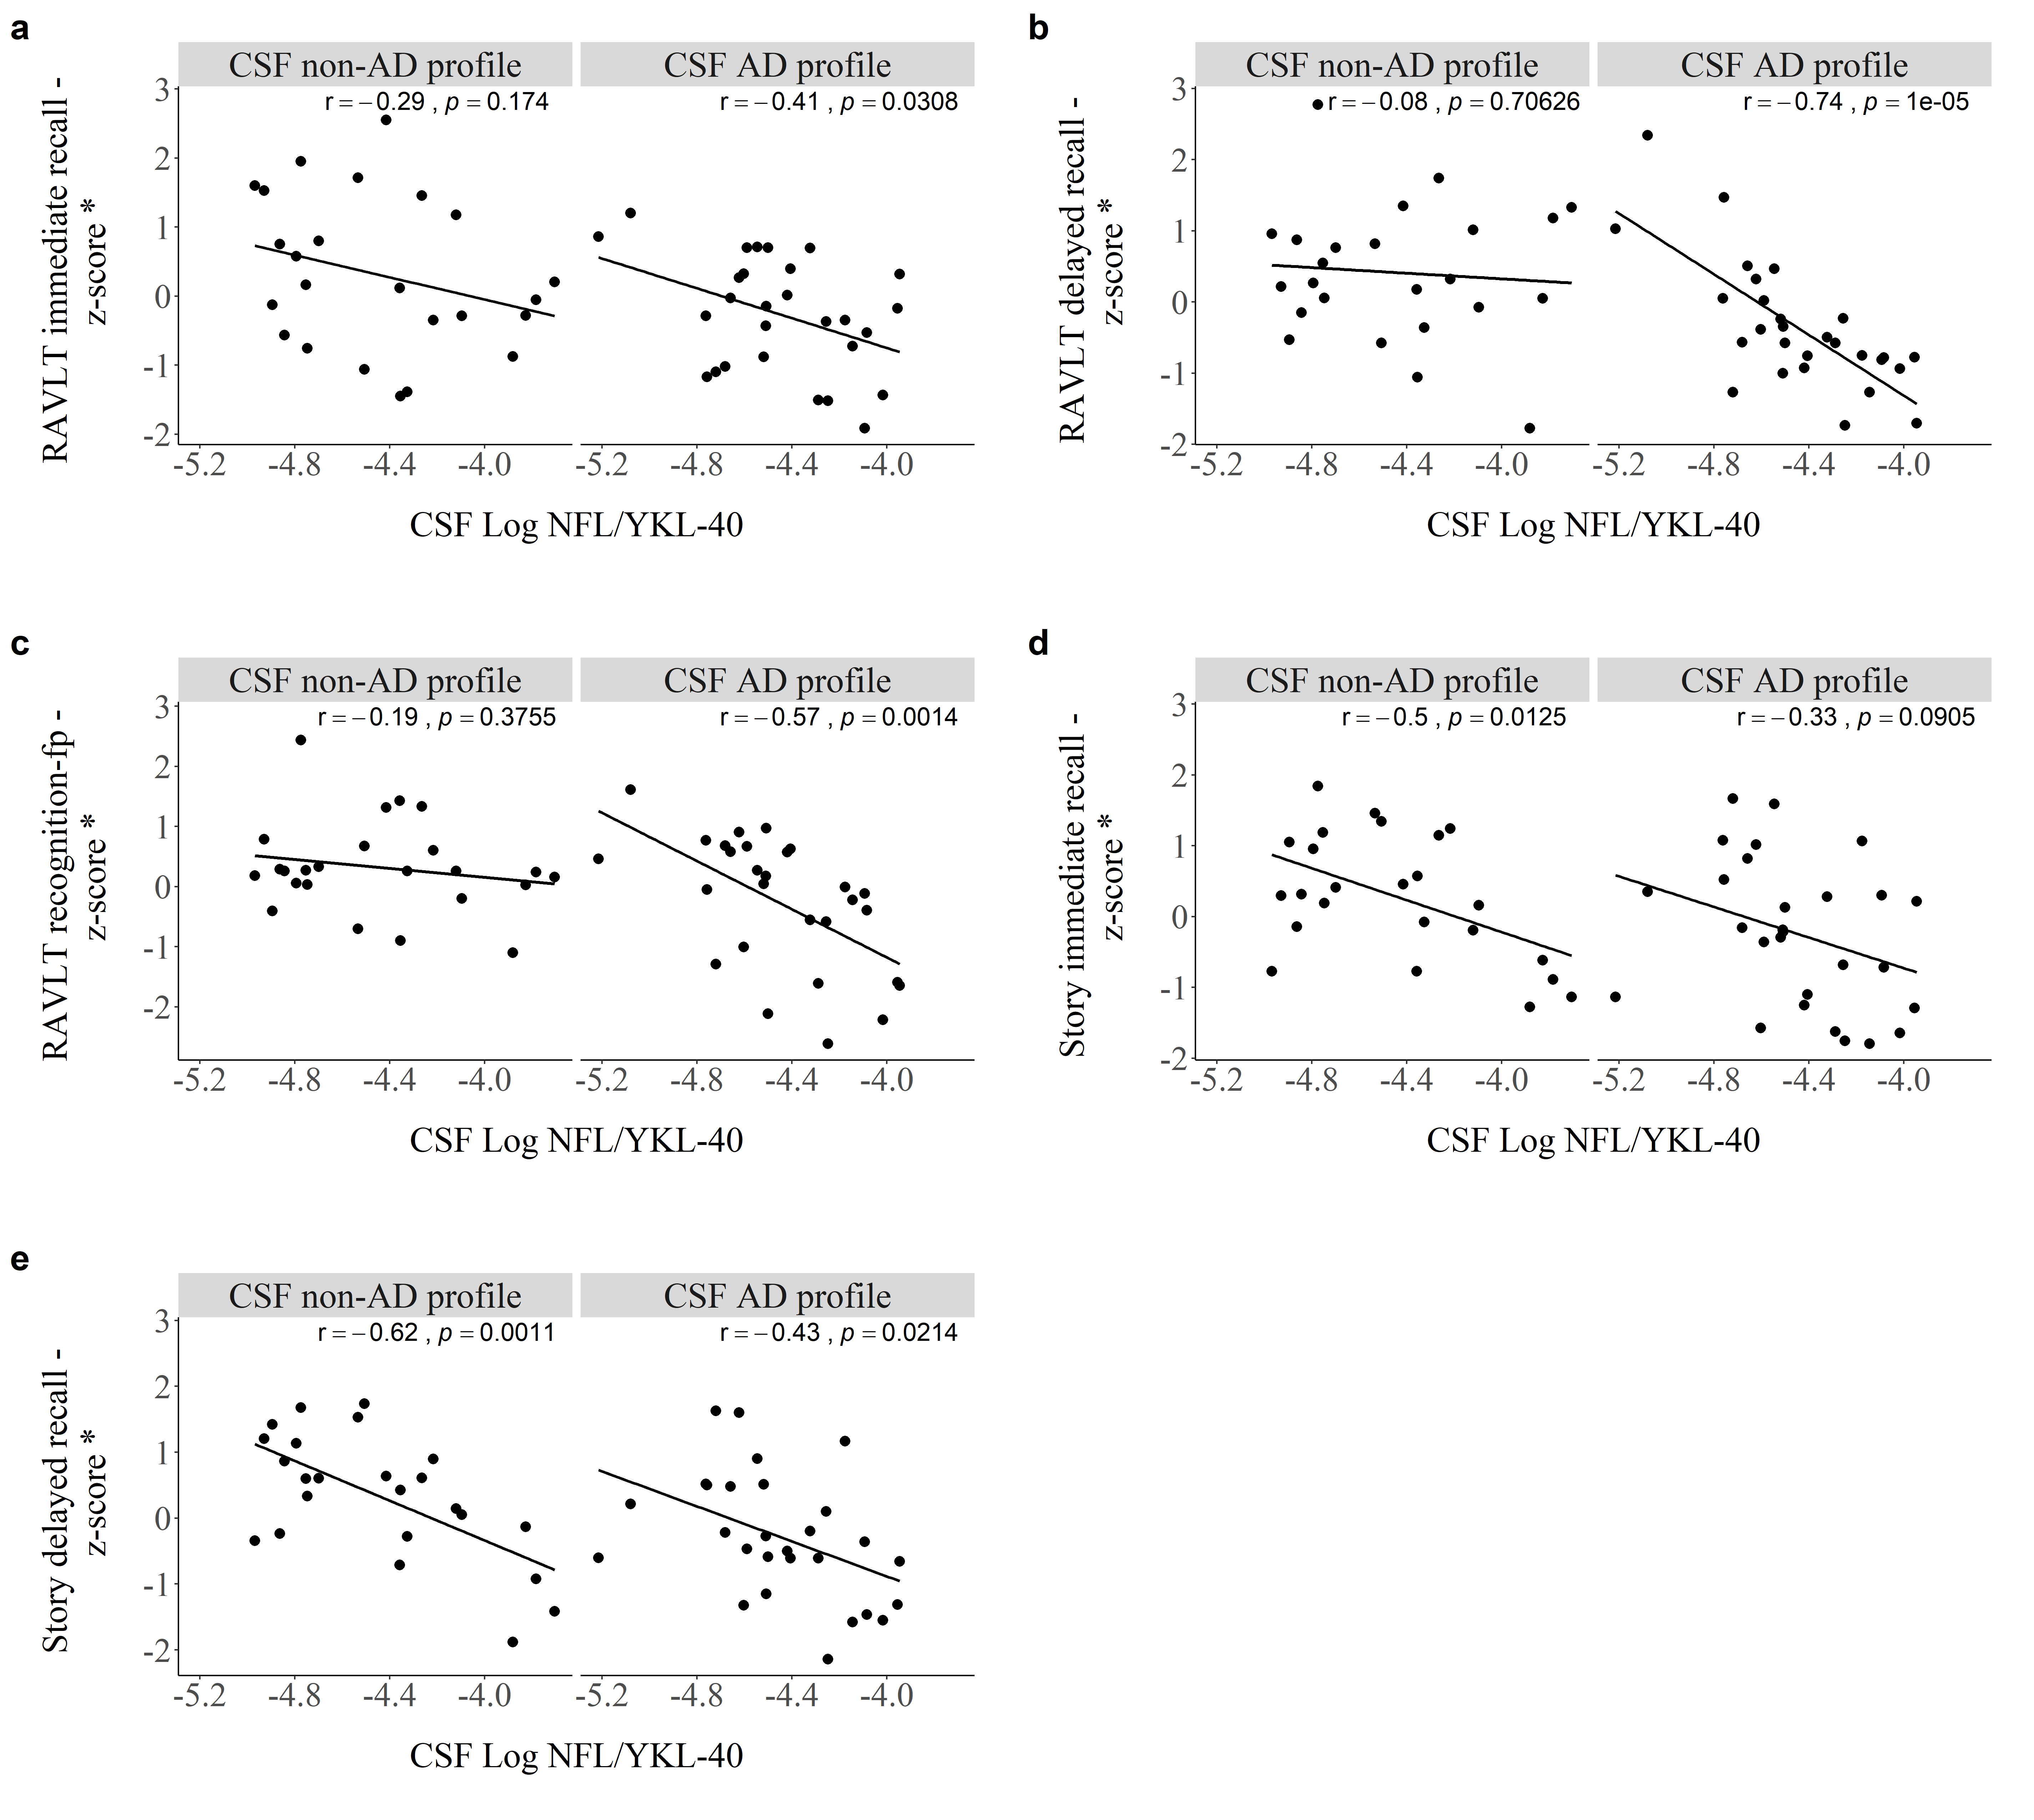
Fig. S2 Pearson‘s correlations between levels of CSF NFL/YKL-40 with a) RAVLT immediate recall, b) RAVLT delayed recall, c) RAVLT recognition – fp, d) Story immediate recall and e) Story delayed recall by CSF profile. *Cognitive domains were adjusted for covariates (age and education)

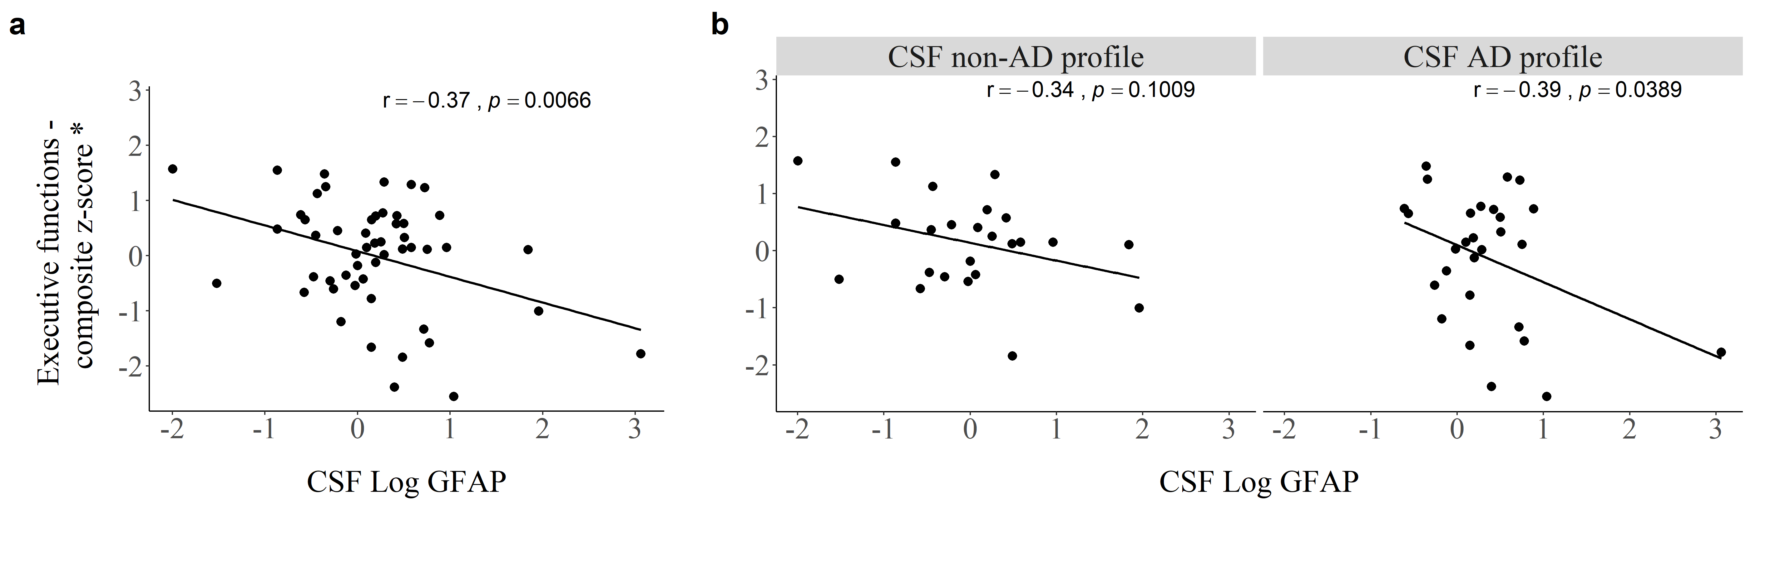
Fig. S3 Pearson‘s correlations between levels of CSF GFAP and executive functions a) within the whole cohort and b) by CSF profile. *Cognitive domains were adjusted for covariates (age and education)

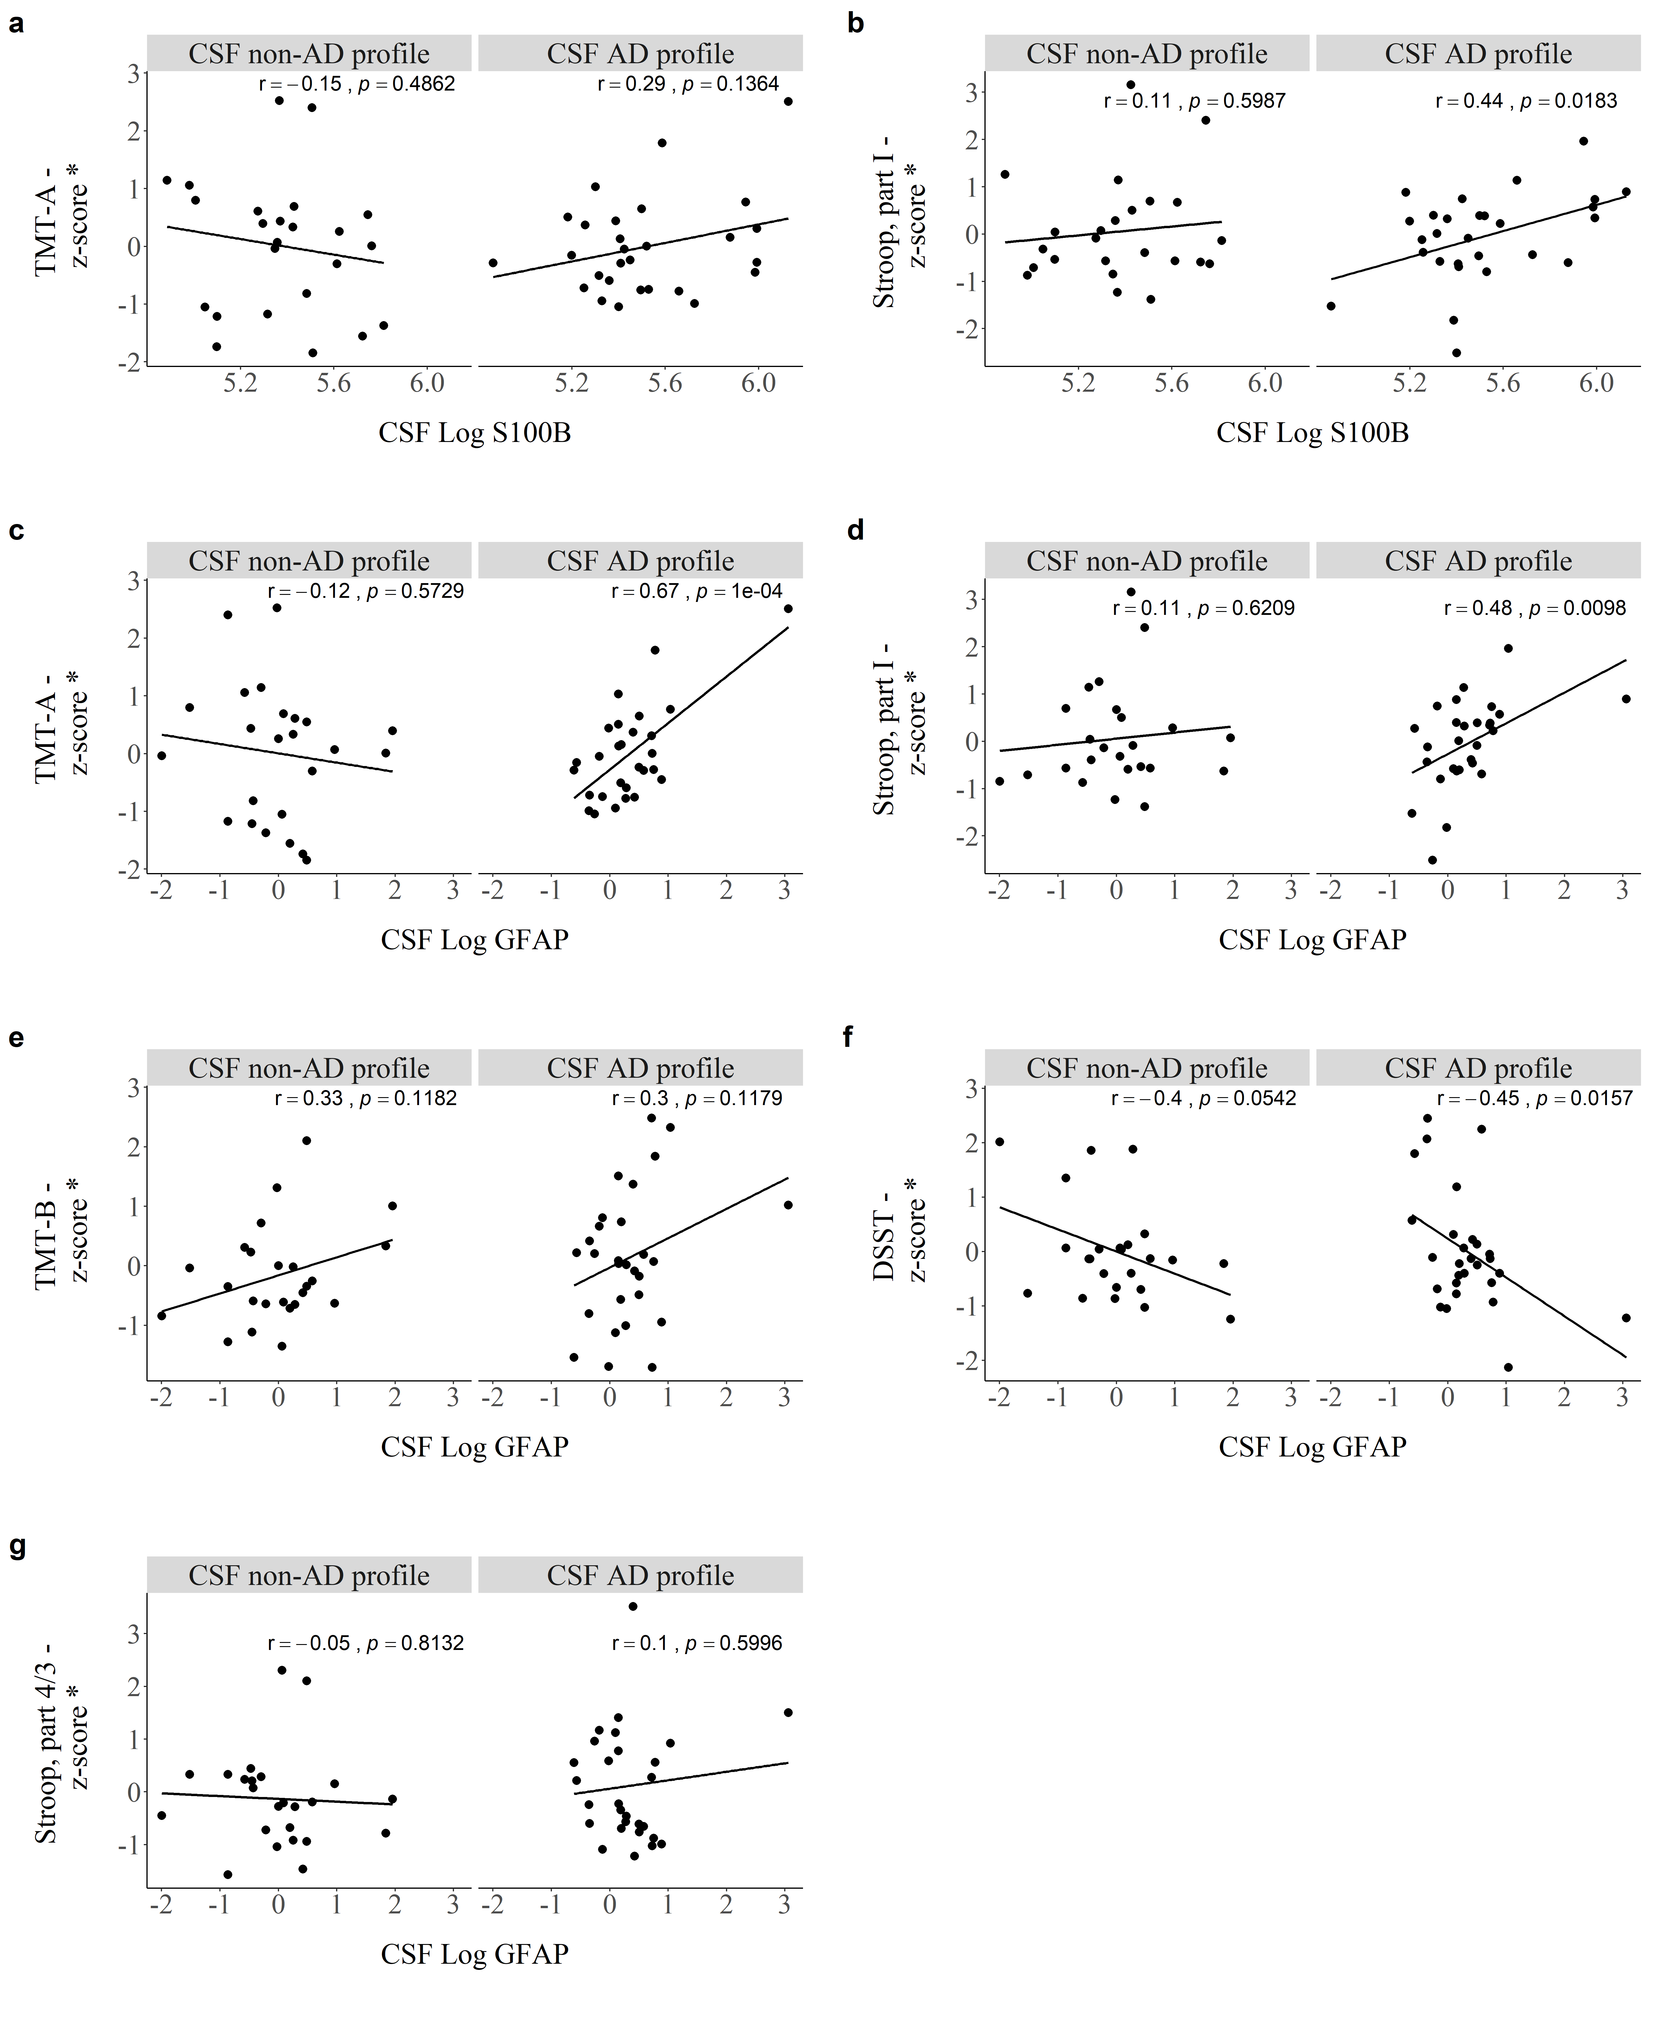
Fig. S4 Pearson‘s correlations between levels of CSF S100B with a) TMT-A and b) Stroop, part I and levels of CSF GFAP with c) TMT-A, d) Stroop, part I, e) TMT-B, f) DSST and g) Stroop, part 4th/3rd by CSF profile. *Cognitive domains were adjusted for covariates (age and education)

